**PIZZA SALES SQL QUERIES:**

**A.KPI’S:**

**1)Total Revenue:**

select round(sum(total_price),2) as TOTAL_Revenue from pizza_sales;

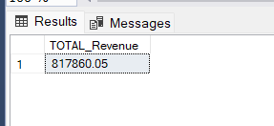

**2)AVERAGE ORDER VALUE:**

select (sum(total_price)/count(distinct order_id)) as AVG_order_value from pizza_sales;

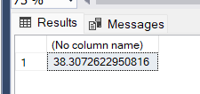

**3)Total Pizzas Sold:**

select sum(quantity) from pizza_sales;

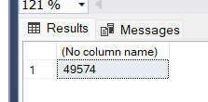

**4)Total Orders:**

select count(distinct order_id)as Total_orders from pizza_sales;

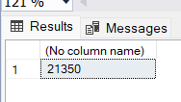

**5)Average Pizzas per order:**

select sum(quantity)/COUNT(distinct order_id) as avg_pizzas_per_order from pizza_sales;

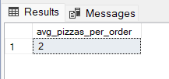

**B. Daily Trend for Total Orders**SELECT DATENAME(DW, order_date) AS order_day, COUNT(DISTINCT order_id) AS total_orders

FROM pizza_sales

GROUP BY DATENAME(DW, order_date);

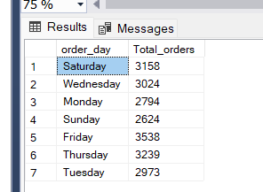

**C. Monthly Trend for Orders**

select DATENAME(MONTH, order_date) as Month_Name, COUNT(DISTINCT order_id) as Total_Orders

from pizza_sales

GROUP BY DATENAME(MONTH, order_date)***Output***

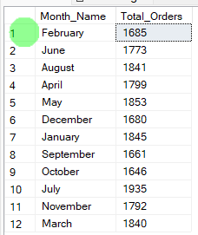

**D. % of Sales by Pizza Category**

SELECT pizza_category, CAST(SUM(total_price) AS DECIMAL(10,2)) as total_revenue,

CAST(SUM(total_price) * 100 / (SELECT SUM(total_price) from pizza_sales) AS DECIMAL(10,2)) AS PCT

FROM pizza_sales

GROUP BY pizza_category

***Output***

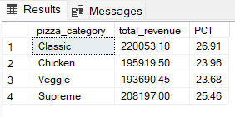

**E. % of Sales by Pizza Size**

SELECT pizza_size, CAST(SUM(total_price) AS DECIMAL(10,2)) as total_revenue,

CAST(SUM(total_price) * 100 / (SELECT SUM(total_price) from pizza_sales where DATEPART(quarter , order_date) = 1) AS DECIMAL(10,2)) AS PCT

FROM pizza_sales

where DATEPART(quarter , order_date) = 1

GROUP BY pizza_size

order by PCT desc;***Output***

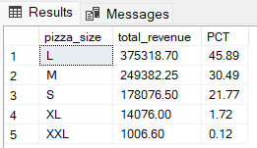

**F. Total Pizzas Sold by Pizza Category**

SELECT pizza_category, SUM(quantity) as Total_Quantity_Sold

FROM pizza_sales

WHERE MONTH(order_date) = 2

GROUP BY pizza_category

ORDER BY Total_Quantity_Sold DESC

***Output***

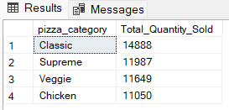

**G. Top 5 Pizzas by Revenue**

SELECT Top 5 pizza_name, SUM(total_price) AS Total_Revenue

FROM pizza_sales

GROUP BY pizza_name

ORDER BY Total_Revenue DESC

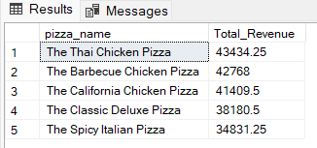

**H. Bottom 5 Pizzas by Revenue**

SELECT Top 5 pizza_name, SUM(total_price) AS Total_Revenue

FROM pizza_sales

GROUP BY pizza_name

ORDER BY Total_Revenue ASC

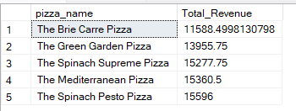

**I. Top 5 Pizzas by Quantity**

SELECT Top 5 pizza_name, SUM(quantity) AS Total_Pizza_Sold

FROM pizza_sales

GROUP BY pizza_name

ORDER BY Total_Pizza_Sold DESC

***Output***

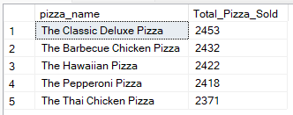

**J. Bottom 5 Pizzas by Quantity**

SELECT TOP 5 pizza_name, SUM(quantity) AS Total_Pizza_Sold

FROM pizza_sales

GROUP BY pizza_name

ORDER BY Total_Pizza_Sold ASC

***Output***

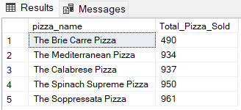

**K. Top 5 Pizzas by Total Orders**

SELECT Top 5 pizza_name, COUNT(DISTINCT order_id) AS Total_Orders

FROM pizza_sales

GROUP BY pizza_name

ORDER BY Total_Orders DESC

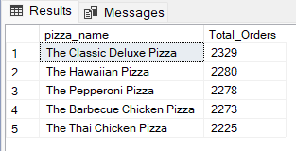

**L. Bottom 5 Pizzas by Total Orders**

SELECT Top 5 pizza_name, COUNT(DISTINCT order_id) AS Total_Orders

FROM pizza_sales

GROUP BY pizza_name

ORDER BY Total_Orders ASC

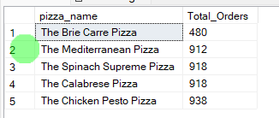

***NOTE***

If you want to apply the pizza_category or pizza_size filters to the above queries you can use WHERE clause. Follow some of below examples

SELECT Top 5 pizza_name, COUNT(DISTINCT order_id) AS Total_Orders

FROM pizza_sales

WHERE pizza_category = 'Classic'

GROUP BY pizza_name

ORDER BY Total_Orders ASC